**Physical Education Lesson #3**

**Hi Kids and Families,**

**Hopefully you were able to find some time to complete the Physical Education Lesson #1 and Lesson #2. Hopefully you were able to find the video and successfully find your pulse! I hope you had fun doing the exercise videos that Mr. Feiss made! Make sure you have an adult with you when you are participating, and wear sneakers, and drink plenty of water!**

 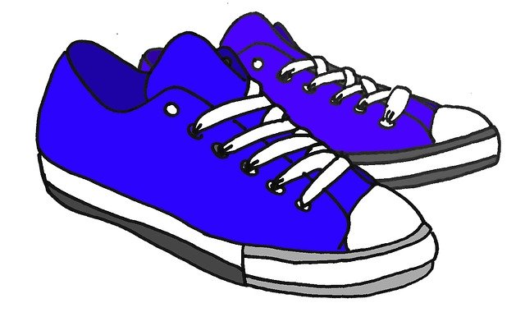

**Please complete the next activity:**

* **We have been working on our warm-up all year. It is now your turn to create your own warm-up! I will give you some ideas and you take it from there. You can have your parent write down what you want to do. You can also draw pictures of your warm-up! Practice the warm-up 2 times. The warm-up should last for 5 minutes! If you aren’t sure what an exercise is from the list below ask your parent nicely to look it up for you on the Internet.**
* **2nd and 1st grade- please have at least 4-5 exercises in your warm-up!**
* **Kindergarten- Please have 2-3 exercises in your warm-up!**

**__________________________________________________________**

PHYSICAL EDUCATION WORD WALL IDEAS FOR WARM-UP

* JOG
* SPEED WALK
* GALLOP
* TOE TOUCHES
* CRAB WALKS
* JUMPING JACKS
* OUT AND INS
* LUNGES
* PLANKS
* STRETCHES
* ANY DANCE MOVES!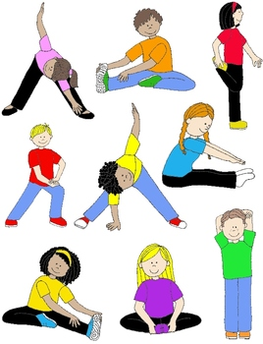
* ARM CIRCLES
* JOG IN PLACE

**Please have fun with this! Stay active and have fun. Talk to you soon!**

**Families just send an email stating that the work was completed. We would love to see your pictures or warm-up list if possible!**

**Mrs. Miller/** [**MillerA@dvsd.org**](mailto:MillerA@dvsd.org)

**Mr. Feiss/** [**FeissJ@dvsd.org**](mailto:FeissJ@dvsd.org)

**\*\*\* PLEASE TRY TO PRACTICE YOUR NEW WARM-UP ON TUESDAY OR WEDNESDAY OF THIS WEEK!!! WERE YOU ABLE TO REMEMBER WHAT THE EXERCISES WERE? HAVE FUN!!!**